**TASK# 1**

**QUES# WRITE A PROGRAM USING SWITCH CASE TO CREATE A SIMPLE CALCULATOR AND PERFORM MATHEMATICAL OPERATIONS ACCORDING TO USER’S CHOICE.**

import 'dart:io';

void main()

{

double? num1,num2;

print("Enter first number = ");

num1=double.parse(stdin.readLineSync()!);

print("Enter Second number = ");

num2=double.parse(stdin.readLineSync()!);

print("Choose an operation +, -, /, % ,*");

String? name = stdin.readLineSync();

switch(name) {

case "+": { print("Sum : ${num1+num2}"); }

break;

case "*": { print("Product : ${num1*num2}"); }

break;

case "-": { print("Diff : ${num1*num2}"); }

break;

case "/": { print("Division : ${num1/num2}"); }

break;

case "%": { print("Mod : ${num1%num2}"); }

break;

default: { print("Invalid option !!!"); }

}

}

**QUES# CREATE A MARKSHEET WITH A SIGNUP FORM ,THE PROGRAM SHOULD CALCULATE STUDENT’S PERCENTAGE AND PRINT GRADE .**

import 'dart:io';

void main()

{

print("-------------- SIGN IN --------------------");

print("ENTER YOUR EMAIL : ");

String email = stdin.readLineSync();

print("ENTER YOUR PASSWORD : ");

String pass = stdin.readLineSync();

print("------------------------------------------");

if(email=="warishaaslam123@gmail.com"&&pass=="123321")

{

num sub1=77,sub2=78,sub3=35,sub4=65,sub5=78,sub6=89,sub7=90,total,per,total_marks=700;

print("\n***** MARKSHEET ******\n");

print("Subjects | Marks\n");

print("English =${sub1}");

print("Maths =${sub2}");

print("Science =${sub3}");

print("Comp =${sub4}");

print("Urdu =${sub5}");

print("Isl =${sub6}");

print("Sst =${sub7}");

if(sub1<40||sub2<40||sub3<40||sub4<40||sub5<40||sub6<40||sub7<40)

{

print("\n");

print("----------------------------------------------");

print("Grade F : FAILED!!!");

}

else{

total=sub1+sub2+sub3+sub4+sub5+sub6+sub7;

per=(total/total_marks)*100;

print("----------------------------------------------");

print("\nPercentage :${per}%\n ");

String grade;

if(per>80)

{

grade="A";

print("Grade : ${grade}");

}

else if((per<80) || (per>70))

{

grade="B";

print("Grade : ${grade}");

}

else if((per<70)||(per>60))

{

grade="C";

print("Grade : ${grade}");

}

else if((per<70)||(per>60))

{

grade="D";

print("Grade : ${grade}\n");

}

}//

}//

else

{

print("Login Failed !!!");

}

}

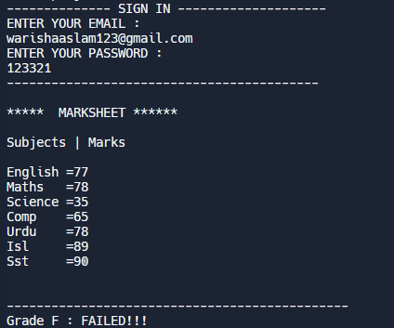

**QUES # WRITE A PROGRAM TO CHECK IF A GIVEN STRING CONTAINS VOWELS OR NOT.**

void main(){

String word="warisha aslam";

word = word.toLowerCase();

int i;

int a=0;

for(i=0; i<word.length; i++ )

{ if(word[i]=='i'||word[i]=='e'||word[i]=='a'||word[i]=='o'||word[i]=='u')

{

a++;

}

}

if(a!=0){

print("word contains ${a} vowels ");

}

else

{

print("no vowels !!!");

}}



**QUES# WRITE A PROGRAM TO CHECK WHETHER A NUMBER IS EVEN OR ODD**

import 'dart:io';

void main(){

print("----CHECK NUMBER EVEN OR ODD---- ");

print("ENTER A NUMBER : ");

int n1=int.parse(stdin.readLineSync());

if(n1%2==0)

{

print('Number is even!');

}

else

{

print('Number is odd!');

}

}

